MICHIGAN SOCCER ASSOCIATION
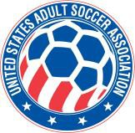Member of the United States Adult Soccer Association
867 South Boulevard ~ Pontiac, MI 48341 ~ (586) 924-2400
2021 CERTIFICATE OF INSURANCE REQUEST FORM

LEAGUE NAME Mailing Address City
League Contact Person
ZIP

Telephone

E-Mail

TEAM NAME

Contact Person

FACILITY OWNER Mailing Address City
ZIP

Telephone

Contact Person

E-Mail

FACILITY NAME
ZIP

Address

City

Requests for Certificates of Insurance (field insurance)
will only be accepted when submitted by the League Administrator to: Michigan Soccer Association at

MiSoccerAssoc@hotmail.com

Questions, please contact Dyann Pugliese at (586) 924-2400.

